FLUE / PROCESS GAS ANALYSER SWG 200⁻¹
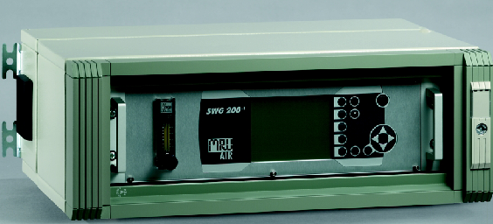

Continuous emission monitoring systems are designed to control and
monitor the emission level of combustion sources or industrial processes.
The standard following components can be measured and indicated:

O2 Oxygen 0 – 25,0 % electrochemical cell
CO Carbon monoxide 0 – 4.000 ppm NDIR bench
CO2 Carbon dioxide 0 – 20,0 % NDIR bench
CH4 Methane 0 – 10.000 ppm NDIR bench

SHORT DESCRIPTION
• The continuous emission analysis is based on infrared bench (NDIR) and long life electrochemical cell.
• The SWG 200-1 will be installed nearly to the gas sampling points, so that there is only
a short distance between the analyzer and the gas sampling point.
This will decrease the response time of analyzer.
The standard length of the non-heated PTFE gas sample line is 10 m.
• The SWG 200-1 is equipped with a complete sample conditioning system.
• The SWG 200-1 is equipped with a standardised digital data interface and analogue
outputs as 0/4-20mA current loop. The measured data will be provided at these outputs.
• Display for analysis data and service data indication are direct in front of the SWG 200-1.
• The SWG 200-1 is designed for continuous measurement. The automatically zero calibration
is occurring at least once a day according to the free user software settings.
• By means of inlets at the bottom of the enclosure, the installation of the power supply 230V / 50Hz,
( 115V / 50-60Hz on request) the gas sampling line, the condense outlet and the data lines are carried out.
• The place of installation SWG 200-1 is in a dry, weatherproof ambient with temperature between
+5°C and +40°C.

HARDWARE
The complete hardware is mounted into a steel cabinet
(weight approx. 30kg, protection IP 43, with 4 fastening loops for wall mounting).
- Lockable glass door
- Local operation keyboard and back lighted LCD display for indication of measured data.
- Complete flue gas conditioning system with:
- Gas sampling pump
- Sample gas cooler
- Automatic condensate draining
- Filter elements for flue gas and ambient air
- Flow meter with needle valve
- Solenoid valve for auto-zero
- ∝-processor electronic board
- Sensors and amplifier electronics, infrared bench
- RS485 interface for long distance data transfer
- 8x analog outputs as 4-20mA current loop

SOFTWARE
Standard software for all aforementioned functions with self-check of all internal functions:
• System diagnosis
• Peltier cooler automatic control
• Sensor functions
• Condensate monitoring
• Automatic and standby operation
• Digital data transmission, including PC visualization software

Analyzer specifications
Measuring principle: | non dispersive infrared, single light source with  electronic modulation, single beam system, multigas  detector for CO, CO2 and CH4, and/or long life  electrochemical cells for O2 , CO, NO and NO2
Measurable components and  measuring ranges : | CO: 0 – 4.000 ppm CO2: 0 – 20 / 40 %  CH4: 0 – 10.000 ppm O2 : 0 – 25,0 %  Other measuring ranges on request
Resolution: | 1 ppm respectively 0,1%
Detection limit: | 20 ppm respectively 0,1%
Repeatability: | +/- 3% FS
Linearity: | +/- 3% FS
Long time zero drift: | none, with automatic auto-zero
Span drift: | ess than +/- 5% FS over 1 week
Temperature effect on zero | none, with automatic auto-zero
Temperature effect on span: | none, internal temperature compensation
Response time: | less than 30 seconds for 90% FS response, from  analyzer inlet port
Warm-up time: | minimum 1/2 hour
Gas sample conditioner: | flow rate: 0,5 l/min  amb. temp.: 0 - 40°C  moisture: less than +5°C dew point  dust: less than 1um  inlet pressure: 700 mbar….1200mbar absolute  inlet/outlet ports: 6 mm fitting
Calibration: | by software, calibration gases for every gas required  clean and dry ambient air for auto-zero purging
Sample gas flow: | flow meter with needle valve, stainless steel,  flow monitoring and alarm
Power supply: | 230 Vac / 50 Hz, 100 W ( other on request)
Electronics: | microprocessor, graphic display with backlight, membrane keypad
Analog output: | up to 8 channel 4 - 20 mA
Digital output: | RS485 for long distance data transfer
Digital input: | 3x potential free voltage, 12V to 24V ac or dc
Electrical connections: | rear panel 19” rack feed-through terminal blocks
Ambient temperature: | +5°C ... +40°C
Ambient humidity: | up to 95% RH , non condensing
Enclosure: | Steel, high protection finish for IP43
Dimensions & weight: | 600 x 220 x 4200 mm ( W x H x D ), 24 kg

Gas sampling probe LD, with in-situ filter

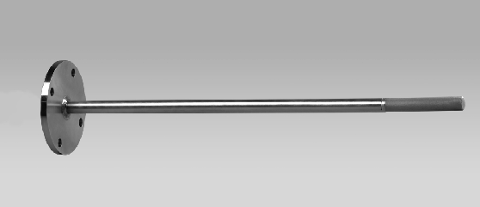

Gas sampling probe for applications with low dust rate, with:
• Stainless steel probe tube length ∅ 22 mm x 250/500/750/1000 mm,
or longer up to max. 2000 mm, for flue gas temperatures up to 500°C
• Inconel steel probe tube length ∅ 22 mm x 500/750/1000 mm,
or longer up to max. 2000 mm, for flue gas temperatures up to 900°C
• Stainless steel 1.4571 (SS316Ti) flange DN65 PN6
• In-situ sintered metal filter 3 um, screwable,
pipe connection for Teflon gas sample line DN6/4
with Teflon gas sample line DN6/4, 10 m
Option:
• Heated gas sample line with:
o exchangeable Teflon hose (PTFE), DN6/4
o 230Vac, 100 W/m
o length 5 m (for other length see price/meter)

Gas sampling probe HD, with heated filter
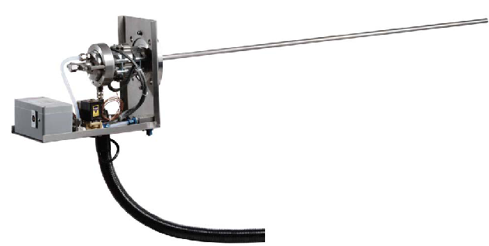
Gas sampling probe for applications with high dust rate, with:
• Stainless steel probe tube ∅ 22 mm x length 250/500/750/1000 mm,
or longer up to max. 2000 mm, for flue gas temperature up to 600°C
• Inconel steel probe tube ∅ 22 mm x length 500/750/1000 mm,
or longer up to max. 2000 mm, for flue gas temperature up to 1100°C
• Ceramic probe tube ∅ 22 mm x length 750/1000 mm,
or longer up to max. 2000 mm, for flue gas temperature up to 1700°C
• Stainless steel flange DN65 PN6
• Heated ceramic filter to approx. 150 °C, easy access for maintenance
• Automatic back purging with oil and water free compressed air, connection 6...10 bar,
• Pipe connection for heated sample line
• Protection cover against the hot surface of the filter
Option:
• Heated gas sample line with:
exchangeable Teflon hose (PTFE), DN6/4
230Vac, 100 W/m
length 5 m (for other length see price/meter)

